MIST352 Homework #1 (100 points)

1. Under the Homeworks folder of your source code repository, create a new Java project named HW1.
   1. Inside the src folder of HW1, create a new java class name HW1 (leave all options as is). **[10 points]**
   2. Delete ALL codes inside the java class you have just created and replace it with the code given in Figure 1.
   3. Identify all errors in the code given in Figure 1. and make the necessary changes to fix all syntax and logical errors in the code. **[25 points]**
   4. Ensure that your program runs without any issues, and it generates the desired output as shown in Figure 2. **[5 points]**
   5. Provide a box of comments on top the class and include each of the next lines as separate comments. Provide the info between the []: **[10 points]**
      1. Author: [Your first and last name]
      2. Class: MIST352-Spring24
      3. HW #1.
      4. [provide your description of what this program does.]
   6. For each line of code, provide one comment above each line, and briefly explain what the error was in that line. For example, the first line in this code should have HW1 instead of HW11., and should have the comment: // Name of the class should reflect the class name **[10 points]**
2. Inside the Homework folder, create a new Java project named HW1B by redesigning the program in HW1 so all necessary data elements are entered from the user. Before you accept each of those variables, your program should display a message asking user for the data. For example, your program should display “Enter value for numberAsString” before assigning a value to the variable numberAsString. **[20 points]**
3. Commit and push all changes to GitHub. Provide “Submitted HW#1” as your commit message. **[10 points]**
4. Navigate to eCampus and make a submission by navigating to the HW1 submission page and simply write “submitted HW1 on GitHub” as your submission. **[10 points]**

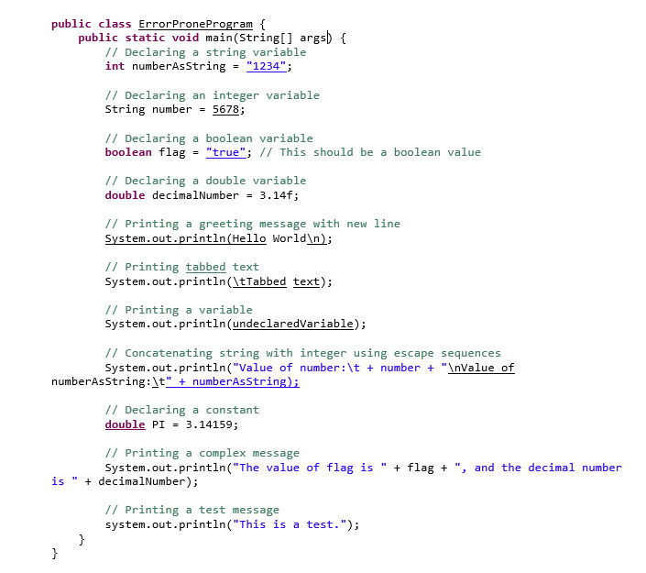

Figure : Code for HW1

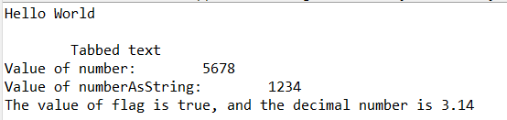

Figure : HW1 output